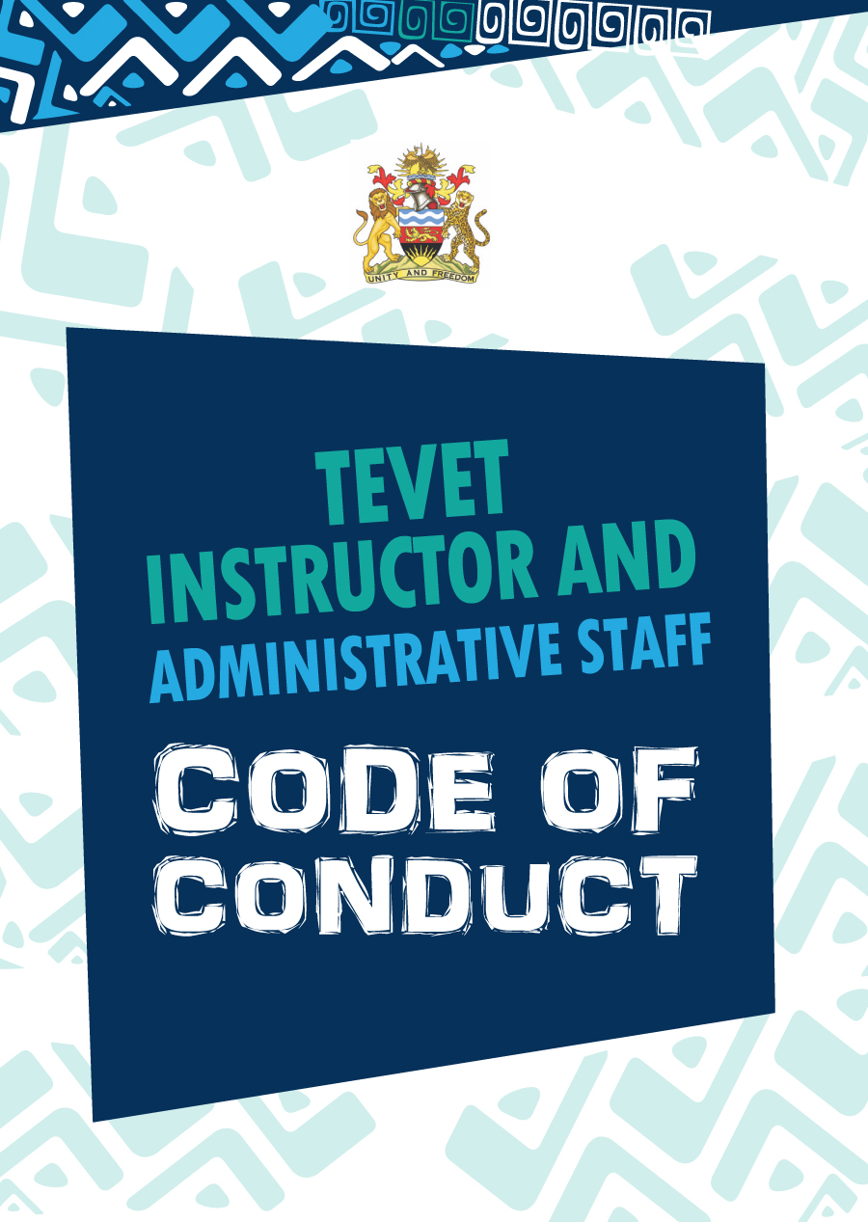



Funded by the European Union (EU) through the UNESCO Skills and Technical Education   
Programme (STEP) in collaboration with the Government of Malawi.

**TABLE OF CONTENTS**

Foreword 2

Introduction 3

Purpose of the Code 3

Structure of the Code 3

1. Core values & Key principles 4

1.1 Core values 4

1.2 Key principles 5

2. General rules 6

3. Professional relationships 6

4. Professional integrity 7

5. Professional conduct 7

5.1 Misconduct 8

6. Professional practice 10

6.1 Instructors 10

6.2 Administrative staff 11

Annex 1: Internal Disciplinary Complaints Procedure 12

Foreword

The Government of Malawi firmly believes that equitable and sustainable economic growth and development can only be achieved if they are built on a solid pool of skilled human resources. Human resources with appropriate technical and vocational skills are the backbone of Malawi’s development and must be harnessed.

The TEVET system is critical in this endeavour, working tirelessly to build a sustainable skilled human resource base that can help Malawi thrive. Yet the system itself is only as good as the staff that work for it. As such, TEVET staff, particularly at college-level, are critical to uphold the quality of training provided, build and maintain trust in the TEVET system and help to ensure that trainees enrol, graduate, and move on to become successful employees or self-employed entrepreneurs in their field of study.

The Code of Conduct provides clear guidelines to TEVET staff on how to conduct themselves in an ethical, respectful and professional manner at their work place, and provides information to the education community and the wider public on the values and expectations of vocational training college staff in Malawi. It is fully aligned with the Gender Equality Act of 2013 and is critical to build and maintain trust in the TEVET system.

I call upon all TEVET instructors and administrative staff at all levels, be they principals, bursars, or secretaries, to embrace their responsibility to lead by example, and abide by the Code of Conduct enshrined in this document.

Malawi’s future is in the hands of our youth and our youths’ future is in TEVET’s hands – your hands!

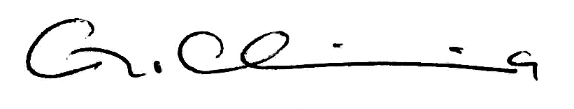

Honourable Grace Chiumia, M.P.

MINISTER OF LABOUR, YOUTH, SPORTS, AND MANPOWER DEVELOPMENT

Introduction

Purpose of the Code

This Code of Professional Conduct applies to all instructors and administrative staff in TEVET colleges, including principals, vice-principals, bursars, secretaries, receptionists, and other support staff. The Code has the following purpose:

* Provision of clear guidelines to instructors and administrative staff on how to conduct themselves in an ethical, respectful and professional manner at their work place;
* Provision of information to the TEVET trainees, education community, and the wider public on the values and expectations of vocational training college staff in Malawi;
* Provision of a clear reference point for the investigation of alleged disciplinary offenses by instructors or administrative staff.

Structure of the Code

The Code first outlines the ethical foundations for TEVET instructors’ and administrative staff’s conduct, which is based on the values of respect, care, integrity, trust, and impartiality. Second, the Code sets out a number of standards central to work at TEVET colleges and expectations of instructors and administrative staff. Last, annex 1 describes the internal complaints procedure that must be followed by anyone who wishes to raise a violation of this Code by an instructor or administrative staff.

1. Core values & Key principles

1.1 Core values

The role of the TEVET system is to facilitate the provision of technical, entrepreneurial, and vocational education and training in Malawi. Its vision is to foster an adequate and competitive workforce for export-led socio-economic growth in Malawi.

Based on this, the Code of Conduct of TEVET instructors and administrative staff is underpinned by the following core values:

* **Respect:** TEVET instructors and administrative staff uphold human dignity and respect for equality, particularly gender equality and equal opportunities for trainees with disabilities. In their professional practice, TEVET instructors and administrative staff demonstrate respect for different spiritual and cultural values, ethnic backgrounds, civil status, family status, age, as well as HIV and socio-economic status.
* **Integrity:** Honesty and moral action embody the meaning of ‘integrity’. TEVET instructors and administrative staff exercise integrity through their professional commitments, responsibilities and actions.
* **Care:** TEVET trainees have entrusted their professional development to instructors and administrative staff. It is the responsibility of instructors and administrative staff to practice their profession with utmost care towards trainees. Instructors and administrative staff must show this through kind and positive professional judgement and empathy in their practice.
* **Trust:** TEVET instructors’ and administrative staff’s professional relationships with trainees and trainees’ family members are based on trust. Trust embodies fairness, accountability and honesty.
* **Impartiality:** TEVET instructors and administrative staff must act with fairness and neutrality and refrain from bias or favouritism at all times.

When entering the profession, TEVET instructors and administrative staff make the following commitments to their trainees and fellow staff:

* Respect the rights of all trainees and staff;
* Safeguard and promote the interests and well-being of trainees and staff, make every effort to create a safe and conducive college environment, and protect trainees and staff from bullying and from physical or psychological abuse;
* Give trainees and staff a feeling of being part of a community of mutual commitment with room for everyone;
* Exercise authority with justice and compassion;
* Ensure that the privileged relationship between instructor/administrator and trainees is not exploited in any way.

1.2 Key principles

The Code is based on the following key principles:

KEY PRINCIPLES

* Maintain professional relationships with trainees, staff and surrounding communities
* Respect the uniqueness and diversity of trainees and staff
* Act with honesty and integrity
* Maintain trust in TEVET staff
* (For instructors): Keep professional knowledge and practice up-to-date
* (For administrative staff): Take responsibility for creating or enabling a   
  safe and conducive college environment

2. General rules

* 1. Attendance, leave, and absence
* Instructors and administrative staff are required to be punctual for all professional engagements and instructors are expected to arrive in class 5 minutes before the official start time.
* Before proceeding on leave, prior approval should be obtained from the Principal. In case of an emergency or illness, the Principal must be informed without undue delay.
  1. Dress code
* All clothing must be appropriate for a professional setting and reflect good taste:

1. Short shorts, very short skirts and dresses, tight shorts and running/gym shorts are not permitted.
2. Use of offensive, obscene, and/or abusive words or symbols on clothing is not permitted. This includes the use of emblems, insignias, badges, or other symbols or lewd or vulgar words where the effect is offensive to a reasonable person or otherwise causes disruption or interference with the orderly operations of the college.
3. Revealing top garments, scooped out at the neck and shoulder, and/or showing excessive amounts of skin area, such as tank tops, halter tops, tube tops or other top garments are not permitted.[1]
4. Trousers must be worn on the waist and underwear must not show.

* All clothing must be suitable for specific practical activities of the instructors’ subject.
* Shoes are to be worn at all times while on duty.

Key principle: Maintain professional relationships with trainees, staff, and surrounding communities

3. Professional relationships

Key principle: Respect the uniqueness and diversity of trainees and staff

Instructors and administrative staff must:

1. Be committed to equality and inclusion and to respecting and accommodating diversity including differences arising from gendered norms, sex, disability, civil status, family status, religion, ethnicity, HIV and socio-economic status, and age.
2. Demonstrate respect for diversity, maintain fairness and promote equality.
3. Contribute to the creation of a fair and inclusive school environment by stopping any forms of discrimination, stereotyping or bullying.
4. Identify and refer to the competent authorities any issues that might impact on trainees’ welfare at the earliest possible stage.
5. Maintain professional relationships with trainees and staff and refrain from any personal or intimate relationships with trainees. Specifically:
6. Maintain professional boundaries whilst in school and out of school. Do not engage in improper physical contact, inappropriate communication via any form of media, or relationships with trainees that are personal or intimate in nature. The members of the teaching profession are duty bound and are ultimately responsible to maintain a professional distance.
7. Conduct pastoral interventions with trainees professionally, and behave in keeping with their unique position of trust and status as role models.
8. Follow behaviour management and safe school policies and guidelines in place at their college.
9. Act appropriately towards trainees and staff exercising care in language, gestures and attitudes, ensuring that they do not act in such a manner that is embarrassing or disparaging and ensuring that they do not use abusive language, offensive names or make disrespectful jokes or remarks.
10. Be fair and committed to the best interests of trainees entrusted to their care, and seek to motivate, inspire and celebrate effort and success.

4. Professional integrity

Key principle: Act with honesty and integrity

Instructors and administrative staff must:

* 1. Comply with policies and procedures applicable to the college.
  2. Represent themselves, their experience, professional position and qualifications honestly.

4.3 Be mindful of their position as a role model to trainees.

4.4 Be sensitive to the need for confidentiality where appropriate.

4.5 Avoid conflict between their professional work and private interests, which could reasonably be deemed to impact negatively on trainees. For instance, when organising job experience and piecework for trainees, act with integrity and transparency, protecting and promoting the best interest of the trainees (not advancing personal gain) and treating all trainees equally and fairly at all times.

4.6 Both in personal and professional life, be mindful of their behaviour and attitude, as that these may have an impact on the profession they represent.

5. Professional conduct

Key principle: Maintain trust in TEVET staff

Instructors and administrative staff must:

* 1. Ensure the safety and welfare of trainees at all times.
  2. Create a conducive learning atmosphere in the classroom and workshop.
  3. Demonstrate maturity and responsibility in their dealings with trainees and staff.
  4. Comply with agreed national policies, procedures and guidelines with aim to promote trainee and staff education, professional development and welfare.
  5. Report incidents, which negatively impact on trainee and staff welfare, particularly those related to inappropriate conduct and sexual abuse, harassment or exploitation.
  6. Ensure that any communication with trainees, staff and their families is appropriate, including communication via electronic media, such as e-mail, texting and social networking sites.
  7. Not be under the influence of any substance, which impairs their fitness to act professionally while on duty.
  8. (For instructors only) Impart the right knowledge to the trainees and implement the approved curriculum.
  9. (For instructors only) Refrain from use of mobile phones during class and practical exercises.

5.1 Misconduct

An instructor or administrative staff shall be guilty of misconduct if he/she:

* + 1. Conducts himself or herself so as not to impair the efficiency of the training centre or college.
    2. Fails to report to duty without good reason.
    3. Refuses or neglects to carry out professional duties and lawful instructions as prescribed in this Code.
    4. Subjects any trainee or staff to sexual violence:

1. *Sexual abuse:* Unwanted physical contact of intimate body parts such as patting buttocks or stroking breast, massaging any part, or deliberate brushing against the body; unwanted attempted sex; physically forced sex; and pressured sex. Pressured sex refers to sex that a person has been pressured to engage in against their will through threats or harassment.
2. *Sexual exploitation:* Demands for sex in exchange for gifts, money, employment or academic favours.
3. *Sexual harassment:* Unwanted verbal or non-verbal conduct, which is sexually suggestive, harassing, offensive, or intimidating. The conduct has the purpose or effect of unreasonably interfering with an individual’s work or academic performance or creating an intimidating, hostile or offensive environment.

Examples of sexual harassment include, but are not limited to:

* Unwanted and persistent explicit or implicit propositions to engage in sexual activity;
* Exposure of sexual body parts;
* Unwanted verbal communication, jokes, written or spoken references to sexual conduct, or sexual gossip;
  + 1. Unwanted non-verbal conduct such as facial expressions, suggestive finger and other body gestures.
    2. Uses his or her position as an employee to further the ends of any political party or organisation.
    3. Is under any statue, adjudged or otherwise declared bankrupt or insolvent or has a writ of civil imprisonment.
    4. Uses for personal gain information acquired through his or her employment in the service.
    5. Has a direct or indirect financial interest in a contract relating to her/his department.
    6. Commits any of the following offences and is convicted thereof by a court of law:

1. Extortion, bribery, corruption;
2. Theft, theft by false pretences, receiving stolen property knowing it to have been stolen;
3. Fraud, forgery, altering a forged instrument knowing it to have been forged;
4. Attempts, incites or conspires to commit an offence under this subsection.

6. Professional practice

6.1 Instructors

Key principle: Keep professional knowledge and practice up-to-date

Instructors must:

* + 1. Maintain high standards of practice in relation to trainee learning, planning, monitoring, assessing, reporting and providing feedback.
    2. Plan and communicate clear, challenging and achievable expectations for trainees.
    3. Create an environment where trainees can become active agents in the learning process and develop lifelong learning skills.
    4. Develop teaching, learning and assessment strategies that support differentiated learning in a way that respects the different needs of female and male trainees, trainees with disabilities and respect the dignity of all trainees.
    5. Be open and responsive to constructive feedback regarding their practice and, if necessary, seek appropriate support, advice and guidance.
    6. Take fullest possible responsibility for the welfare and professional achievements of trainees under their supervision during trainee attachments.
    7. Act in the best interest of trainees.
    8. Take personal responsibility for sustaining and improving the quality of their professional practice by:
* Actively maintaining their professional knowledge and understanding to ensure it is current;
* Reflecting on, and critically evaluating, their professional practice, in light of their professional knowledgebase.  
  + 1. If selected to be on the Disciplinary Committee, act with utmost integrity and professionalism.

6.2 Administrative staff

Key principle: Take responsibility for creating or enabling a safe and conducive college environment

Administrative staff must:

6.2.1 Take responsibility for creating a safe, hospitable and supportive college environment where trainees can be healthy, feel secure, and learn:

* Ensure that all college physical structures, including hostels, are well-maintained, safe, kept in hygienic conditions and are managed in a manner that respects trainees’ dignity;
* Ensure, to the extent possible, that food served at college canteens is safe and nutritious;
* Ensure that, to the extent possible, critical trainee services are provided and kept in good working order (eg. libraries, career counselling, etc).

6.2.2 Carry out their responsibilities with care, integrity and due respect for diversity and the promotion of equality, especially in any work relating to admissions, recruitment and promotions, and financial matters.

6.2.3 Be open and responsive to constructive feedback regarding their work and, if necessary, seek appropriate support, advice and guidance.

6.2.4 Act in the best interest of the college, the staff, and the trainees at all times.

6.2.5 If selected to be on the Disciplinary Committee, act with utmost integrity and professionalism.

Annex 1: Internal Disciplinary Complaints Procedure

**OBJECTIVES**

The objectives of the Disciplinary Complaints Procedure are as follows:

1. To establish an institutional framework to deal with violations of the Instructor and Administrative staff Code of Conduct in a transparent and just way.
2. To, in particular, encourage victims of sexual abuse, exploitation, or harassment to exercise their rights and maintain their dignity.
3. To take action in addressing violations of the Instructor and Administrative staff Code of Conduct and impose corrective action as is necessary, including disciplinary action where appropriate.

**PRINCIPLES**

1. Confidentiality

1.1 Any person handling a case of misconduct and any party to the case shall treat it with confidentiality except  
where disclosure is necessary to prevent imminent harm.

1.2 Anonymous complaints are permitted.

2. Frivolous or false accusations

2.1 A trainee or member of staff who makes a frivolous, malicious and vexatious or false accusation of misconduct against another person is committing a disciplinary offence.

**PROCEDURAL MATTERS**

3. Disciplinary Committee

3.1 Each College shall set-up a Disciplinary Committee.

3.2 The Committee shall be composed of persons of high integrity of with a minimum of 40% and no more than 60% of either sex.[2]

* 1. The Committee shall be ordinarily composed of a minimum of 60% staff.

3.4 The composition of the Committee shall comprise a pool of approximately 5-7 people, depending on the total number of staff at the college, including:

1. The Vice-Principal;
2. 2 to 4 Staff Representatives (1-2 female and 1-2 male);
3. Two Student Union Representatives (1 female and 1 male).



3.5 In cases where both the accused and the complainant are members of staff and the nature of the complaint does not involve staff conduct towards trainees per se, the Committee shall not include any trainee representation.

3.6 Quorum: The Committee shall be able to conduct its business if a minimum of 3 people, including at least one woman, one trainee, and one staff representative are present. In exceptional cases outlined in point 3.5 above, the minimum composition is 3 members of staff, including at least one woman.

3.7 The Vice-Principal shall be the chairperson of the Committee. In case the Vice-Principal is absent, the Committee shall vote on a replacement chair from within their members by majority vote.

4. Submission of reports of misconduct

4.1 Any trainee or member of staff can make a report of misconduct.

4.2 There are two forms of reports of misconduct:

1. An informal report of misconduct;
2. A formal report of misconduct.

5. Informal report of misconduct

5.1 Any member of the College community, who believes that she or he has witnessed or experienced a violation of the Instructor/Administrative staff Code of Conduct, but is not ready to lodge a formal report, can lodge an informal report of misconduct.

5.2 An informal report of misconduct is made directly to the Principal or Vice-Principal verbally or in writing, except for alleged cases of sexual violence, which can be reported to any academic or administrative college staff, or trainee representative verbally or in writing.

5.3 In case of a verbal report, the person who receives the verbal report is responsible for writing-up the complaint within 1 week of receipt.

5.4 An informal written complaint shall contain:

1. Name and address of the complainant (optional)
2. Date of the report
3. Nature and details of the act or conduct reported
4. Any other relevant matter concerning the report of misconduct

5.5 An informal written report on sexual violence, including sexual abuse, sexual exploitation and sexual harassment, should include the following:

1. Name and address of the complainant (optional)
2. Date of the report
3. Time and place of each incident
4. The conduct and words involved in the incident
5. The victim’s response
6. The names of any witnesses; and
7. Any other relevant matter concerning the incident

5.6 The informal report of misconduct shall be forwarded to the Disciplinary Committee for recording by the member of staff or trainee representative who has received the complaint in writing within 1 week of receipt of the complaint.

5.7 The informal report of misconduct remains on record by the Disciplinary Committee and may be used in future as evidence of repeated misconduct.

5.8 The person who has received the complaint must inform the accused of the report lodged against him/her verbally or in writing within 1 week of receipt of the complaint.

5.9 The person who has received the complaint is responsible for identifying an appropriate resolution to the misconduct reported within 2 weeks of having received the complaint and needs to communicate the resolution to the complainant and accused within this time frame.

5.10 The person who has received the complaint can recommend and offer support to the complainant to lodge a formal complaint.

5.11 The person who has received the complaint must produce a final written report detailing the misconduct and the action taken or recommended and send to the Chair of the Disciplinary Committee for onward submission to the Director of the Technical and Vocational Education and Training Department at the MoLYSMD.

5.12 The member of staff or trainee representative who has received the complaint is responsible to follow-up regularly over a period of 2 months to ensure the resolution is adequately acted upon.

6. Formal report of misconduct

6.1 Any member of the College community who believes that he or she has witnessed or experienced a violation of the Trainee Code of Conduct can lodge a formal report of misconduct.

6.2 A formal report of misconduct can be made to any member of the Disciplinary Committee verbally or in writing. If a verbal complaint is made, the member of the Disciplinary Committee is responsible for writing-up the complaint within 1 week of receipt of the complaint.

6.3 A formal written complaint shall contain

1. Name and address of the complainant (optional)
2. Date of the report
3. Nature and details of the act or conduct reported
4. Any other relevant matter concerning the report of misconduct

6.4 A formal written report on sexual violence, including sexual abuse, sexual exploitation and sexual harassment, should include the following:

1. Name and address of the complainant (optional)
2. Date of the report
3. Time and place of each incident
4. The conduct and words involved in the incident
5. The victim’s response
6. The names of any witnesses; and
7. Any other relevant matter concerning the incident

7. Consideration of nature of formal reports of misconduct

7.1 The Disciplinary Committee will consider each formal report of misconduct received and decide on whether the nature of the misconduct is such that it can be investigated internally or whether it warrants referral to the police for investigation.

7.2 The decision of whether or not to investigate the report internally will be reached by majority vote within 1 week of receiving the complaint. It will be based on the gravity and frequency of the misconduct and whether or not the misconduct is criminal in nature as stipulated by Malawi national law.

7.3 If the Disciplinary Committee decides that the misconduct warrants external investigation by the police, it will hand-over the complaint to the police within 1 working day of reaching the decision. The Disciplinary Committee will follow the external investigation and keep the outcome of the investigation on file.

7.4 If the Disciplinary Committee decides that the misconduct is best dealt-with internally, a hearing will be held (see section 8 below).

7.5 Regardless of progress of the external investigation, the welfare and safety of trainees and staff must be guaranteed, which might warrant the temporary suspension of the accused.

8. Hearings for formal reports of misconduct

8.1 A hearing will be held within 1 week of receipt of the formal report of misconduct.

8.2 A friend or colleague may accompany the complainant or the accused to the hearing.

8.3 In cases of alleged sexual abuse, harassment or exploitation, the complainant and accused shall not be required to be in the same room at the same time.

8.4 In cases of alleged sexual abuse, harassment or exploitation, the complainant or accused shall not be allowed or required to unnecessarily and repeatedly recount the events complained of, as recounting the experience of sexual abuse, harassment, or exploitation is difficult and can damage the party’s personal dignity

8.5 An accused person who has been summoned and fails to attend the hearing without good reason that is communicated in writing ahead of the hearing commits an offense and shall be dismissed.

9. Investigation

9.1 The Committee shall carry out an investigation of the reported misconduct with independence, objectivity and with due diligence and respect for rights of both the complainant and the accused.

9.2 Any member of the Committee who is connected with the allegation in any way shall be excluded from the process.

9.3 A report of misconduct shall be investigated, and concluded, within one week after receipt of the written report of misconduct, except in special circumstances.

10. Resolution

10.1 The Committee will vote on an appropriate resolution of the reported misconduct within one week of having held the hearing and conducted the investigation following the principle of simple majority voting.

11. Communication of resolution

11.1 The resolution will be communicated verbally and in writing to the complainant and the accused within one week of having reached the resolution.

11.2 A final written report detailing the misconduct and the action taken or recommended must be produced and sent to the Director of the Department of Technical and Vocational Education and Training at the MoLYSMD within one week of having reached the resolution.

12. Penalties

12.1 A person found guilty of misconduct, if employed directly by the college, shall, depending on the gravity of the offence, be liable to any or a combination of the following issued by the Committee:

1. Written warning
2. Ordered to give a public apology to the aggrieved party
3. Ordered to compensate the aggrieved party
4. Suspension
5. Dismissal
6. Demotion
7. Transfer

12.2 A person found guilty of misconduct, if employed as a civil servant by the MoLYSMD, shall, depending on the gravity of the offence, be liable to any or a combination of the following penalties issued by the Committee:

1. Written warning
2. Ordered to give a public apology to the aggrieved party
3. Ordered to compensate the aggrieved party

12.3 Where the Committee finds the most appropriate penalty to be more severe, the Committee can recommend the following penalties to the MoLYSMD:

1. Suspension
2. Dismissal
3. Demotion
4. Transfer

12.4 The penalties given by the Committee shall not preclude the complainant from seeking remedy/remedies provided by the national judicial framework.

13. Appeal

13.1 In case the complainant or the accused feel aggrieved by the decision of the Committee, they may, within 2 weeks, appeal against the decision.

13.2 An appeal can be, in the first instance, raised with the Principal, college Board of Directors, or the Board of Governors.

13.3 Should no solution be found in the first instance, the aggrieved party can, within a further 2 weeks, raise an appeal with the Directorate of Technical, Entrepreneurial, and Vocational Education and Training at the MoLYSMD.

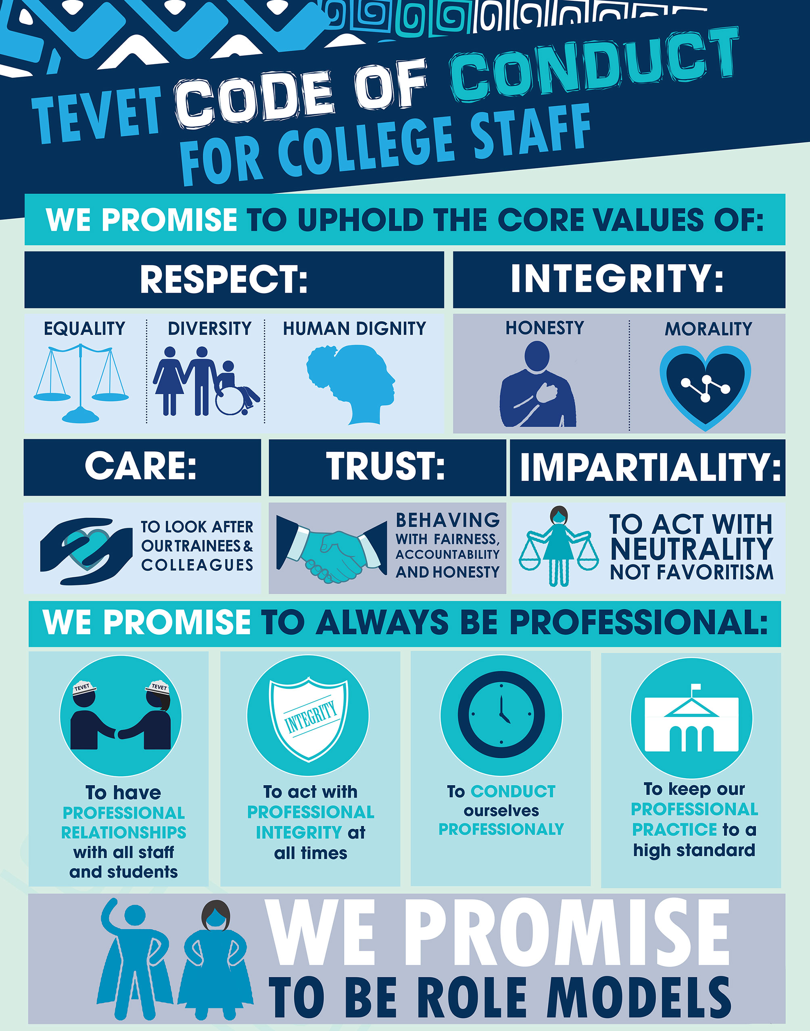

1. The supervising administrative staff shall determine if a particular mode of dress violates the above rules.
2. Gender Equality Act, 2013.